JENKINS PROJECTS CICD with SCM

**Jenkins:**

**Jenkin installation**

**Os-ubuntu:**

Step1:

**Java installation**

**Jdk:**



**Jenkin installation:**

**Enable and Start the Jenkins :**

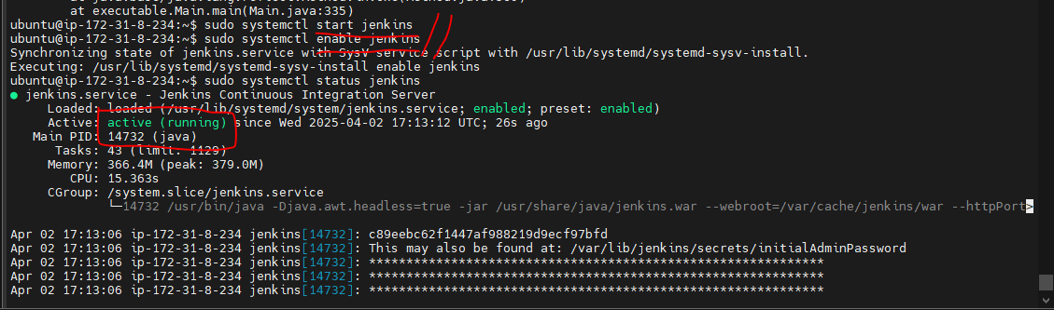

**Step2**:

**LOGIN JENKINS:**

Go to browser put public ip address with 8080 port number default

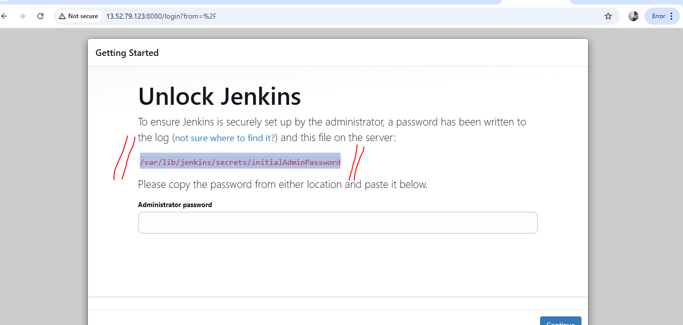

How to get the Administrator Password :

Copy the path go to machine using cat command to get the code:

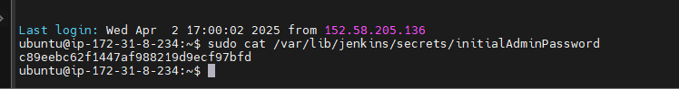

**Configuration:**

Set the username and password (own)

**Plugin installations:**

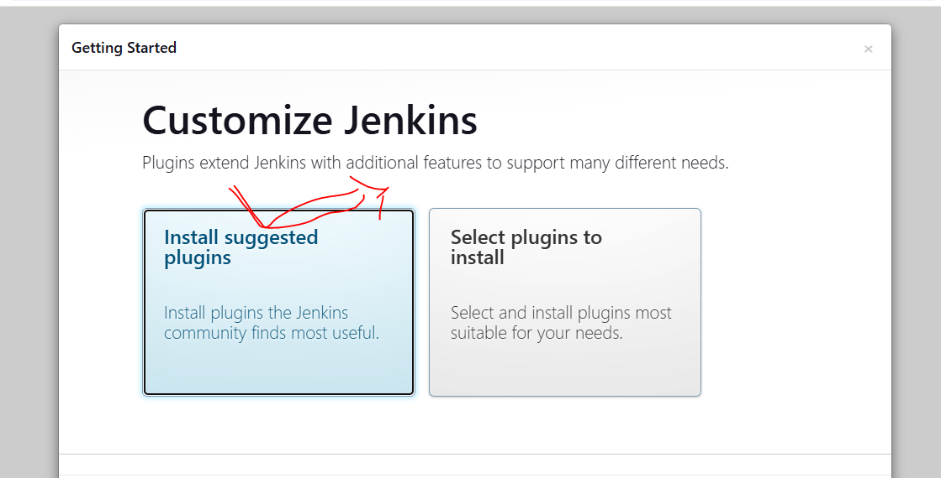

**After completing the installation, you have to moved to set username and password :**

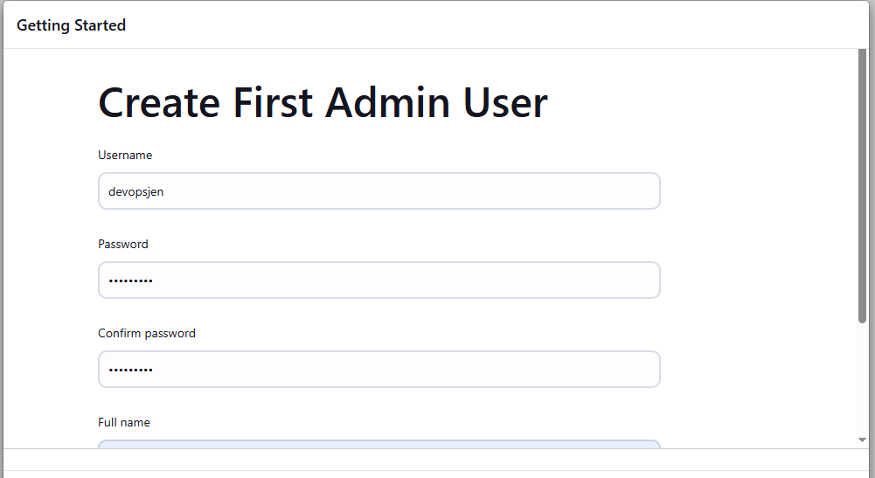

URL: [http://youripadress:8080/](http://13.52.79.123:8080/)

ready to use the jenkins

Finally get Jenkin job page:

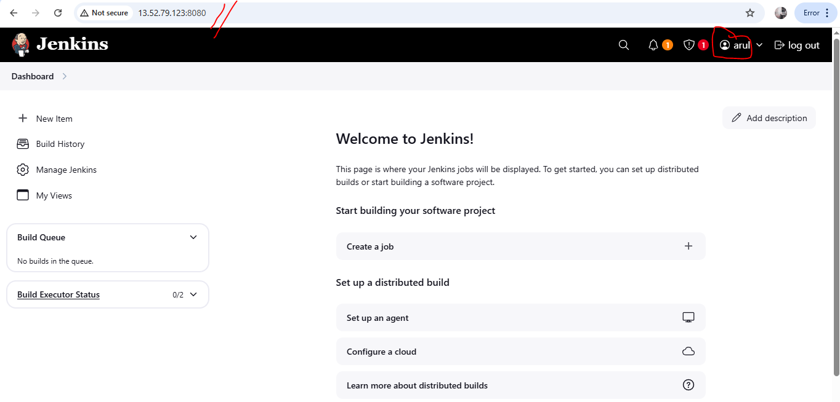

**Global tools configuration: via Managejenkins**

**1.Maven tool**

**2.Git**

**3.jdk**

**Images:**

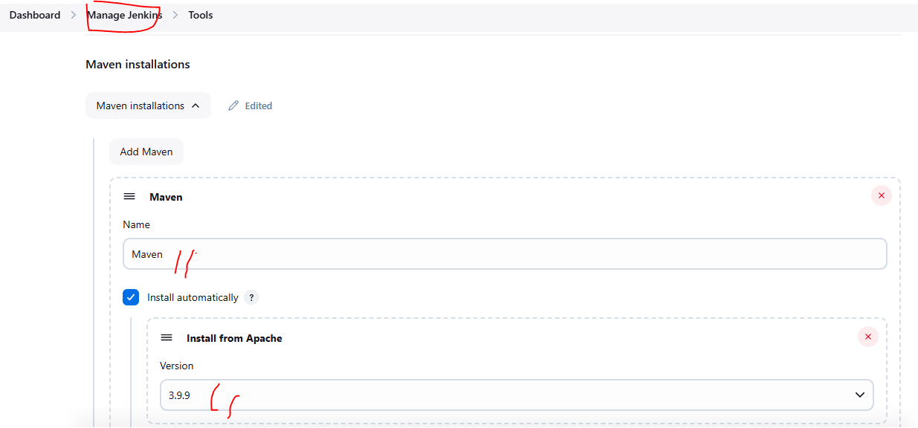

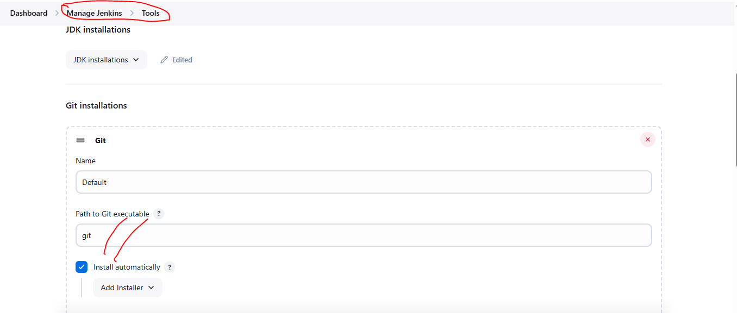

INSTALLATION AND CONFIGURATION COMPLETED

**Project creation:**

**CICD PIPELINE**

**SCRIPTEDTYPE**

**DECLARTIVE TYPE**

**i have to create the cicdpipeline project based on the below mentioned steps:**

**Got to Jenkins DASHBOARD**

**Select newitem**

**name: pipelineproject**

**Select the which type of project: pipeline**

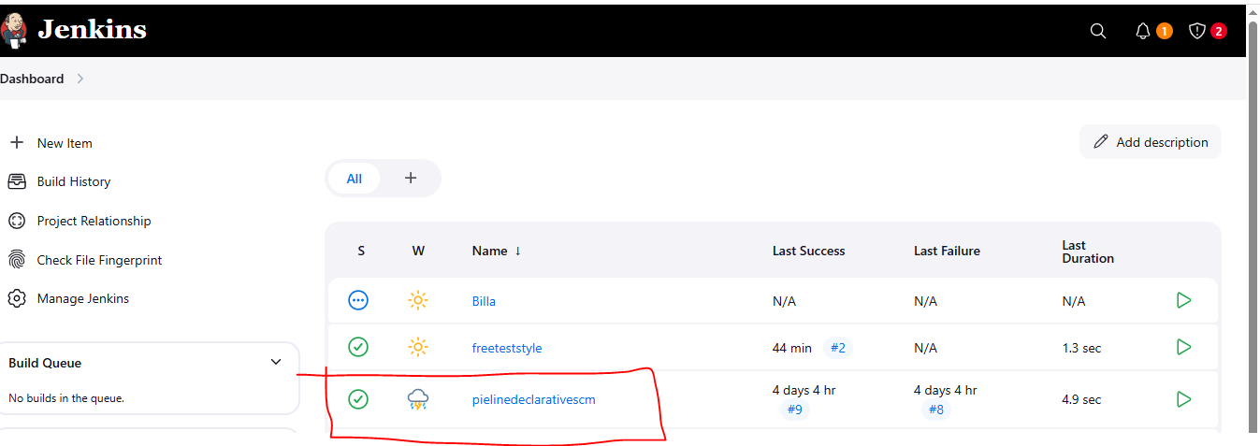

**Select the pipelinedeclarative project go to Configure**

**First i have to write the Description (project name) then got to pipeline**

**In the pipeline I add the Buildsteps ---- choose the Pipelinescript**

**Write a code using Declarative pipeline syntax**

**code:**

**pipeline {**

**agent any**

**stages**

**{**

**stage('checkout')**

**{**

**steps**

**{**

**git 'https://github.com/jglick/simple-maven-project-with-tests.git'// repository url used to get a code**

**}**

**}**

**stage('build') {**

**steps {**

**echo 'buildjenkinsjob'**

**}**

**}**

**stage('test')**

**{**

**steps {**

**echo 'testjenkinsjob'**

**}**

**}**

**stage('deploy')**

**{**

**steps {**

**echo 'deployjenkinsjob'**

**}**

**}**

**}**

**}**

**images:**

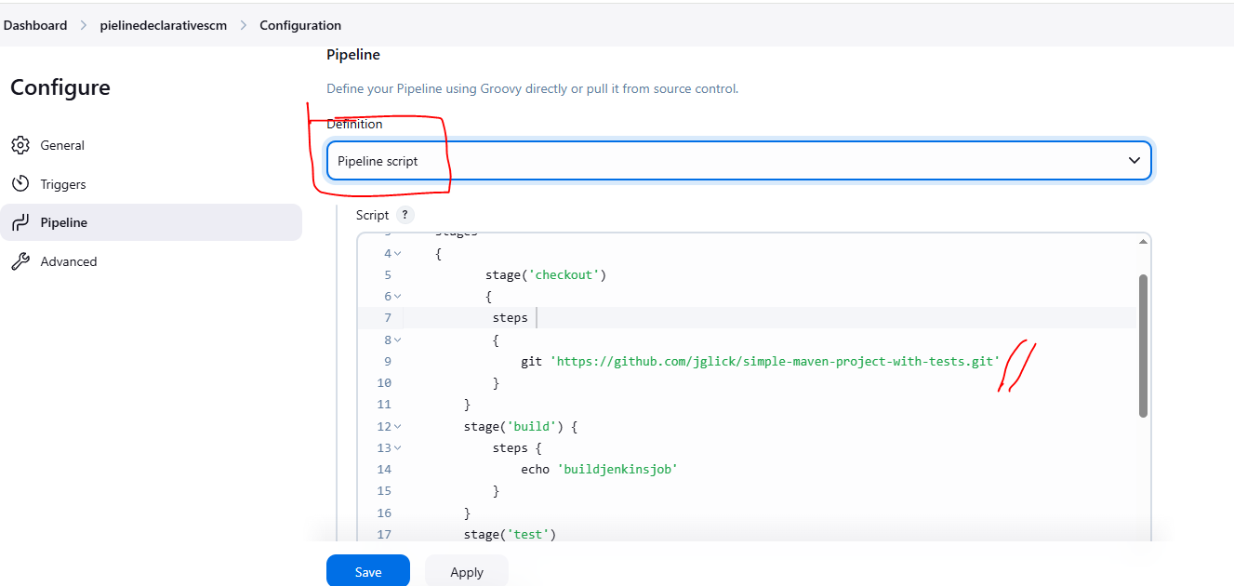

**Apply and Save the configuration**

**Build the Jenkins Job:**

**Run a job click the Buildnow**

**It will take a time to run a program to execute the result**

**This is the build for pipeline job jenkins** 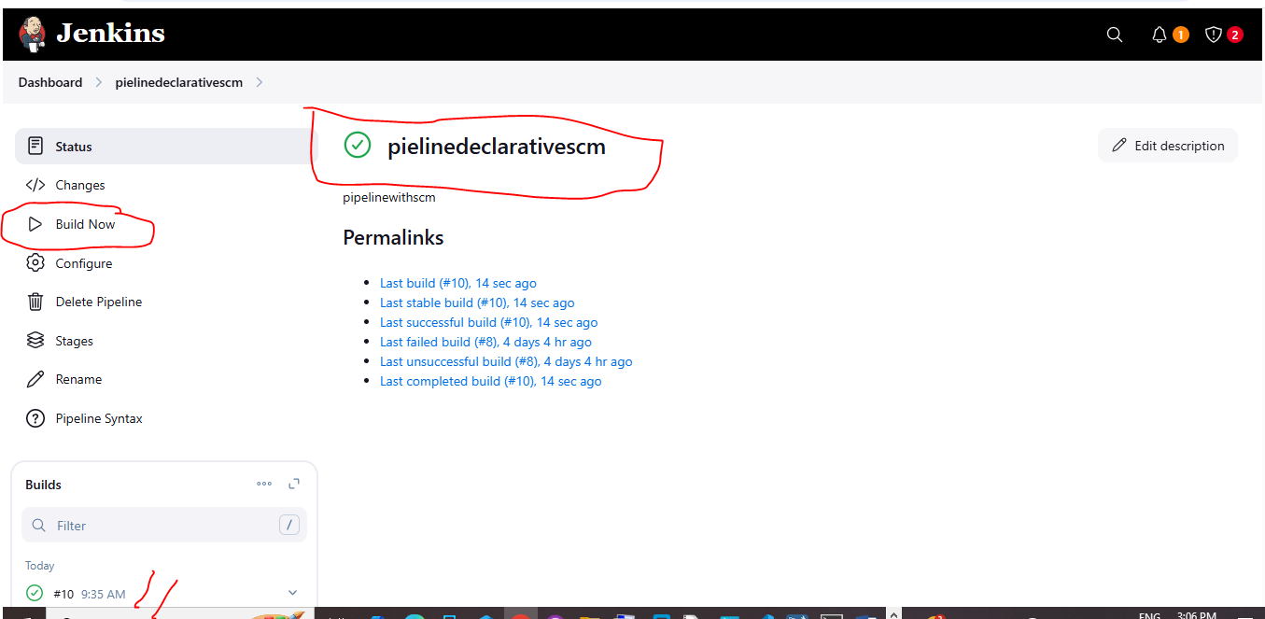

**Check the output:**

**Finally get the build success for project**

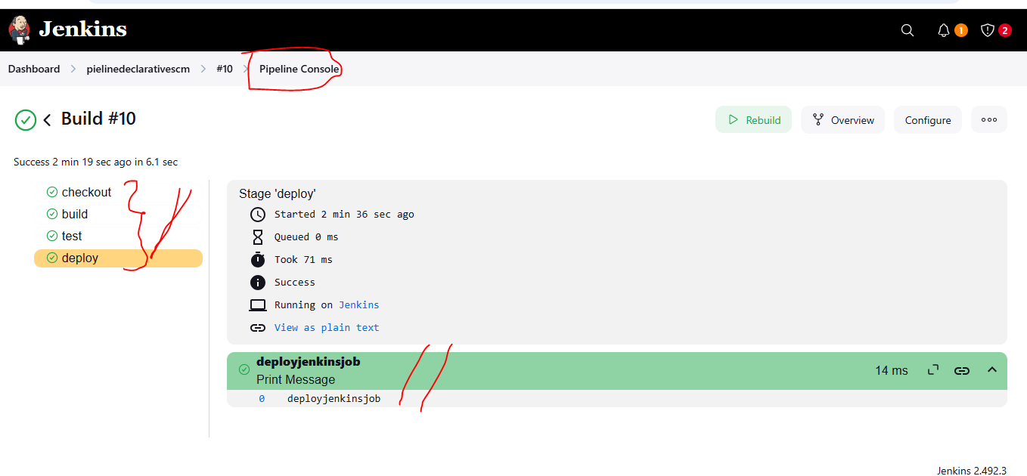

**Project2:**

**Pipeline script with scm:declarativetype**

**We have to follow the above steps upto pipeline then choose pipelinescript +scm**

**Steps:**

**First we should add the github with creadintional & path configuration into configuration part**

**Git:scm**

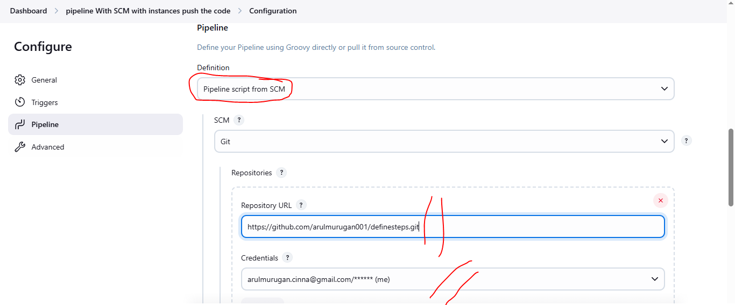

**PATH:**

**Path configuration don in the Adnvance : file name should be write “Jenkinfile”**

**Verify the Filename git hub repository**

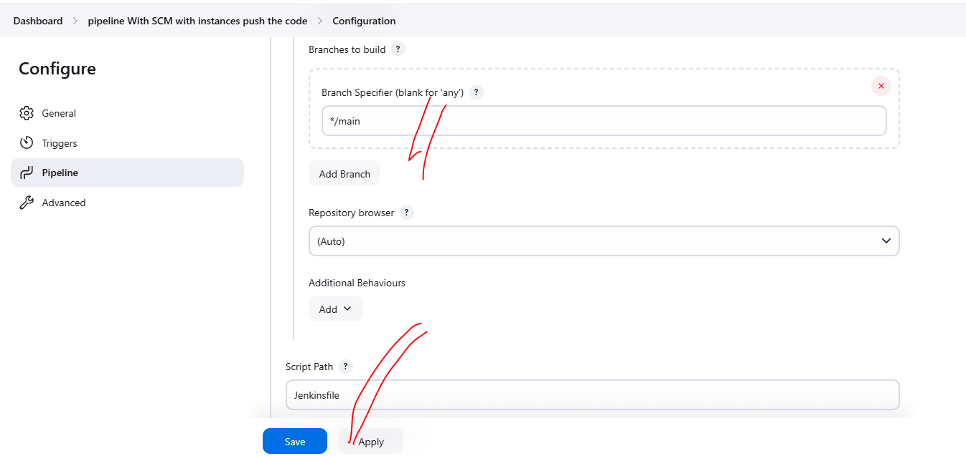

**Github and jenkinfile creation:**

**Locally created Jenkinsfile without any extension (using any editor) inside the file write a code then finally moved or pushed into the githubrepository**

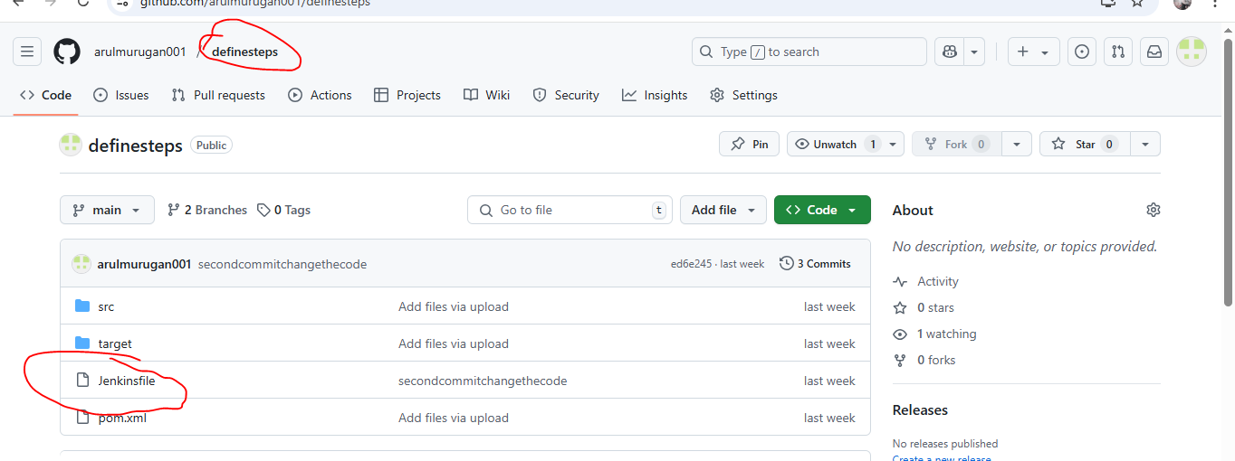

**Code already written into the Jenkins file save it then push.**

**Code:**

**write this script using pipelinesyntax**

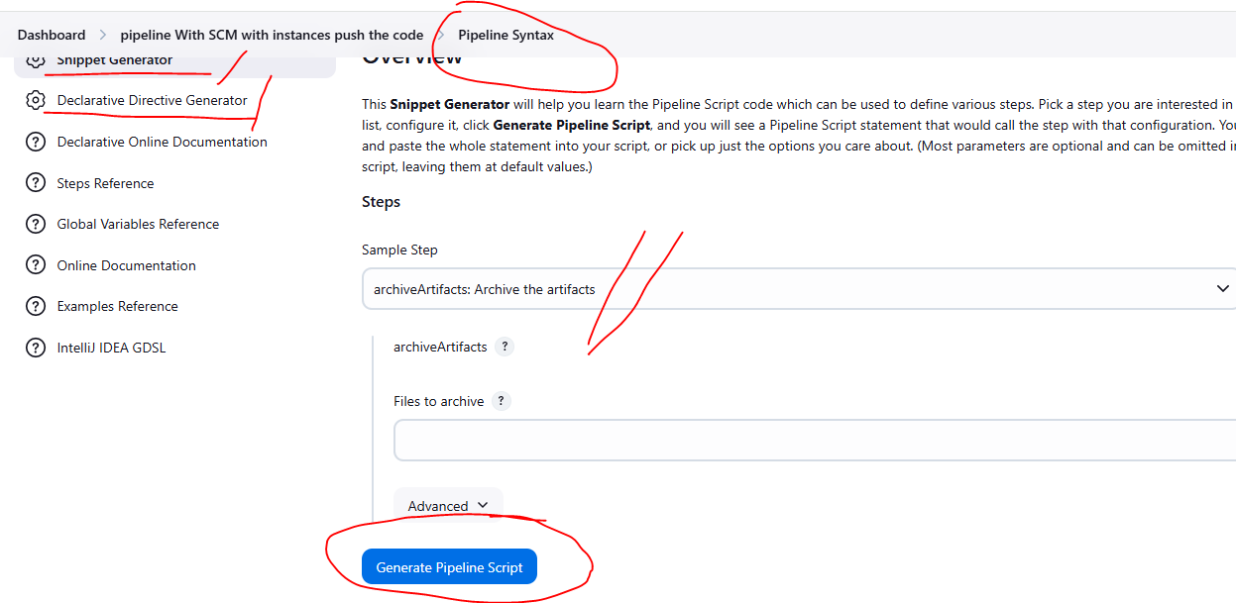

**pipeline {**

**agent any**

**tools {**

**maven 'Maven' // Optional: remove if not using Maven**

**}**

**stages {**

**stage('Checkout') {**

**steps {**

**git url: 'https://github.com/arulmurugan001/definesteps.git', branch: 'main' // clone the repository**

**}**

**}**

**stage('Build') {**

**steps {**

**sh 'mvn clean install'**

**}**

**}**

**stage('Test') {**

**steps {**

**sh 'mvn test'**

**}**

**}**

**stage('Package') {**

**steps {**

**sh 'mvn package'**

**}**

**}**

**}**

**post {**

**success {**

**echo 'Build completed successfully file created by Arul murugan.'**

**}**

**failure {**

**echo 'Build failed!'**

**}**

**always {**

**junit '**/target/surefire-reports/*.xml'**

**archiveArtifacts '**/target/*.jar' // jar file configuration**

**}**

**}**

**}**

**Save and apply**

**Buildnow the Project**

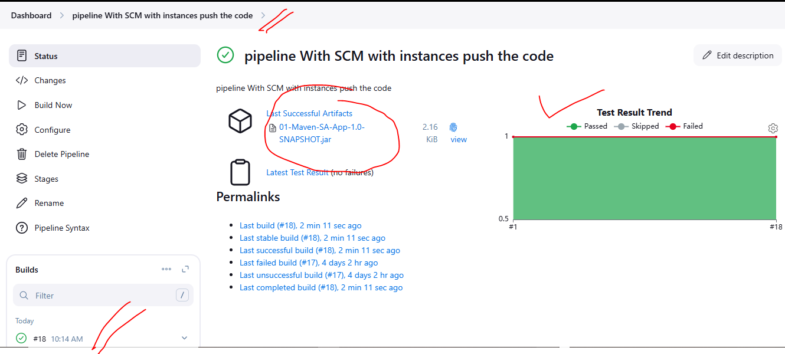

**Output :**

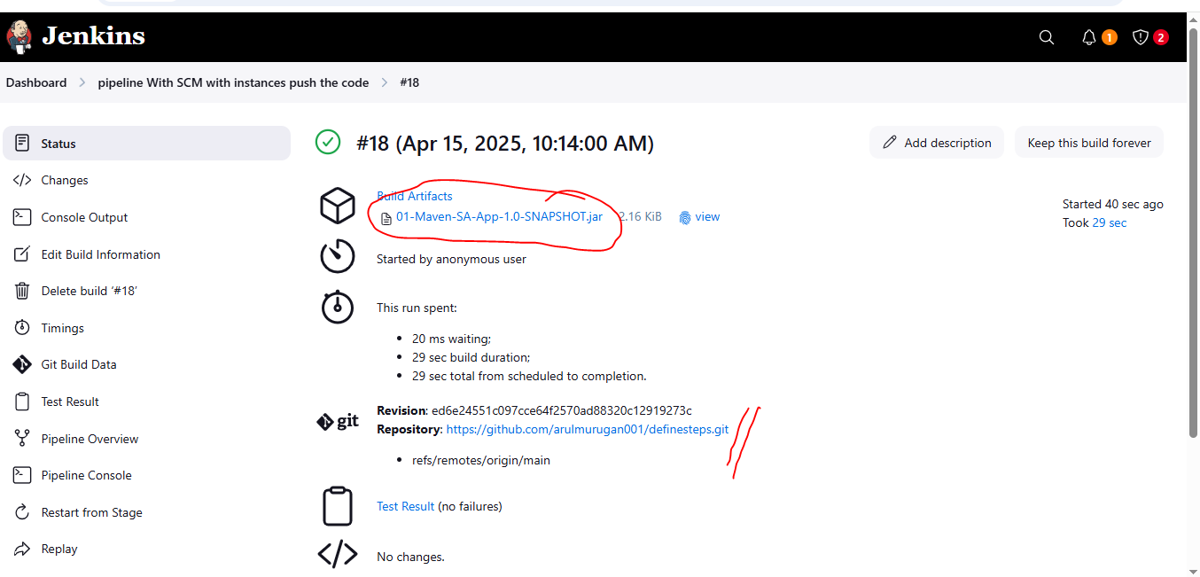

**Pipeline consoleview**

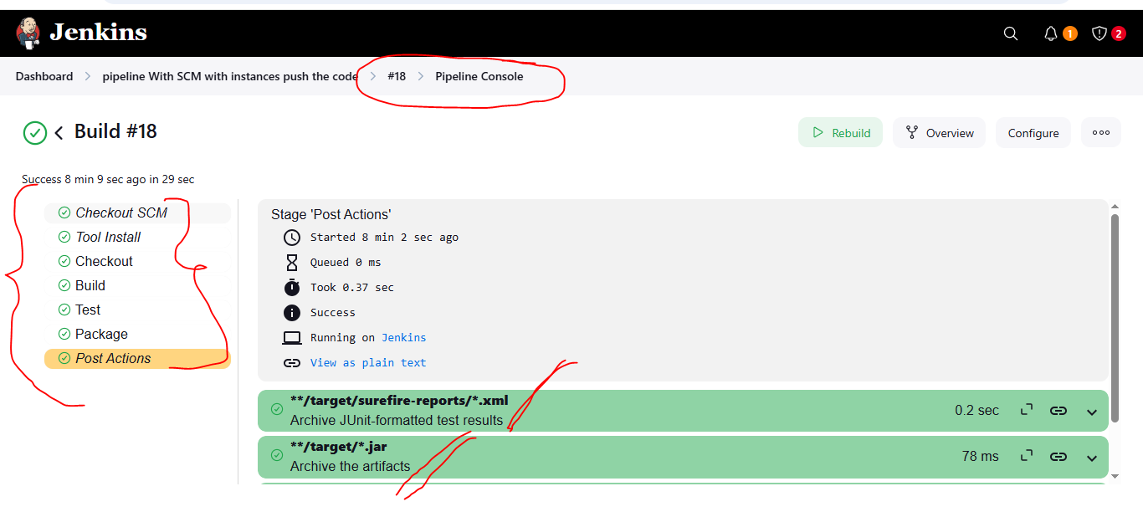

**url:**

**https://github.com/arulmurugan001/definesteps.git**